**Prolog Assignment**

**By**

**Jason Antigua**

**&**

**Niaz Ahmed**

**PROLOG**

1. Let us consider the following set of facts that describe the mother predicate.

mother(linda, paul).

mother(cathy, andrew).

mother(cathy, laura)

* Define a predicate female(X) which holds iff X is a female
* Define a predicate sister(X,Y) which holds iff X and Y are sisters
* Implement female and sister in PROLOG
* Provide screenshots

Definition for female(X) predicate: female(X) :- X = cathy; X = linda; X = laura.

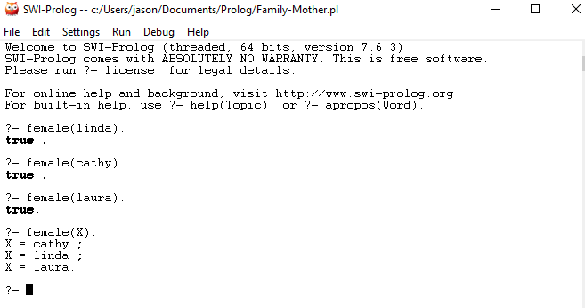

I assumed you only want linda and cathy to be sisters since they’re both mothers and a daughter cannot also be a sister to her mother so that is the only combination that works. My definition is:

sister(X,Y) :- mother(X,Person1), mother(Y,Person2),

X \= Y, Person1 \= Person2.

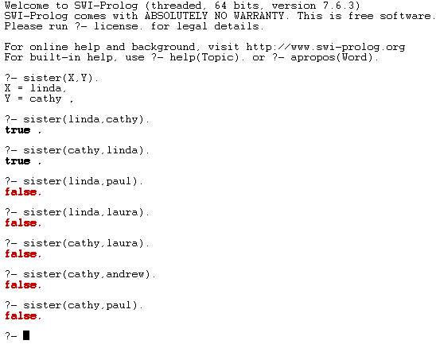

1. Implement the function g such that g(x) = x+5.

My definition for function g(x) = x+5 is: g(X,5,Y) :- Y is X+5.

